Lab 6

download.file("http://www.openintro.org/stat/data/ames.RData", destfile ="ames.RData")  
load("ames.RData")  
  
population <- ames$Gr.Liv.Area  
samp <- sample(population, 60)

## Exercise 1: Plot a histogram of your sample of living areas. Then, describe the shape, center, and spread of your histogram. What would you say is the “typical” living area within your sample? Explain.

summary(samp)

## Min. 1st Qu. Median Mean 3rd Qu. Max.   
## 759 1106 1386 1470 1744 3194

hist(samp, main = "Area of Houses in Ames Iowa", xlab = "Area")

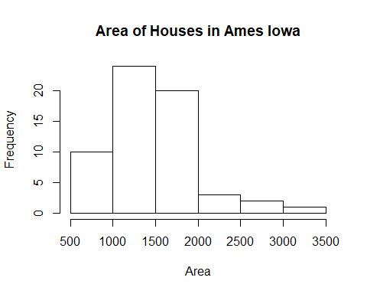

mean(samp) #The mean of the area

## [1] 1469.55

sd(samp) #The standard deviation of the area

## [1] 505.5726

### The shape of the data is right skewed. The mean is 1469.55, while the standard deviation is 505.5726

## Exercise 2: Would you expect another student’s sample distribution to be identical to yours? Would you expect it to be similar? Why or why not?

### No, I would not expect another student’s sample distribution to be identical to mine. The population is large and the possibility of obtaining the same 60 records is small.

## Confidence Intervals

sample_mean <- mean(samp)  
se <- sd(samp)/sqrt(60)  
lower <- sample_mean - 2 * se  
upper <- sample_mean + 2 * se  
c(lower, upper)

## [1] 1374.818 1611.582

## Exercise 3: For a one-sample t confidence interval to be valid, the sampling distribution of the sample mean must be normally distributed. Check this assumption using the indirect methods demonstrated during class. (Note: If any outliers are present in your sample, you will need to include the relevant calculations to classify the outlier(s) as being either mild or extreme. Extreme outliers prevent us from applying the Central Limit Theorem.)

shapiro.test(samp) #Shapiro Wilk Test of samp

##   
## Shapiro-Wilk normality test  
##   
## data: samp  
## W = 0.97176, p-value = 0.1779

boxplot(samp) #Boxplot of samp

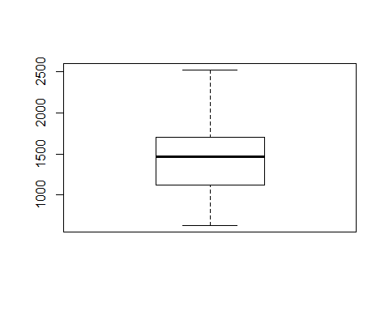

#qq Norm of Samp  
qqnorm(samp)   
qqline(samp, col=2,lwd=2,lty=2)

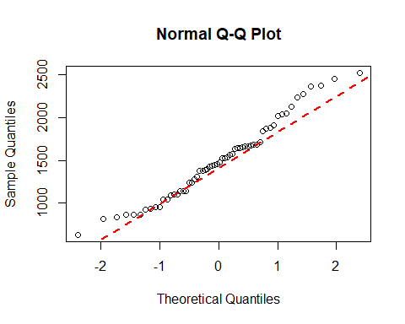

### Given that the Q-Q plot shows curvature, the boxplot is right skewed (but no outliers), and the Shapiro-Wilk P value of 0.1779 < .25. I cannot assume that the population is normal. Since this is a sample of 60 (which is greater than 30) and that there are no extreme outliers, I can still assume that the sampling distribution is normal.

## Exercise 4: Report your 95% confidence interval in the form... Then, carefully interpret your confidence interval in context

### 1374.818 < u < 1611.58. We are 95% confident that the living area of houses located in Ames, Iowa is between 1374.818 feet and 1611.58 feet.

## Exercise 5: What does the phrase “95% confident” mean? In other words, give an interpretation of the confidence level.

### The phrase “95% confident” means that the sample data is close to correlating with the population data. The data is stable and if the experiment was repeated, the results would be about the same.

## Exercise 6: Did your confidence interval capture the true mean living area of houses in Ames? Explain.

mean(population) #The mean of the population

## [1] 1499.69

### Yes, the confidence interval captured the true mean of living area of houses in Ames. The mean of 1499.69 lies between 1374.818 and 1611.58.

## Exercise 7: Each student in your class section should have gotten a slightly different confidence interval. What proportion of those intervals would you expect to successfully capture the true population mean? Why? Write your confidence interval on the board. When everybody has done so, write down the confidence intervals created by all of the students in your class section and calculate the proportion of these intervals that successfully captured the true population mean. How does this proportion compare to the expected proportion? Why might it be different? Explain.

source('Lab6_class_results.R') #Constructed file with values from class  
  
#will print in range if population mean is between upper and lower values. Will print not in range if the population mean is not between the upper and lower values  
for(i in 1:length(class_upper)){  
 cat("\nStudent #",i)  
 if((class_lower[i] <= mean(population)) & (mean(population >= class_upper[i]))){  
   
 low <- cat(" - lower:", class_lower[i])  
 high <- cat(" upper:", class_upper[i])  
 cat(" in range")  
 }else  
 {  
 low <- cat(" - lowe:", class_lower[i])  
 high <- cat(" upper:", class_upper[i])  
 cat(" not in range")  
 }  
}

##   
## Student # 1 - lower: 1399.875 upper: 1627.891 in range  
## Student # 2 - lower: 1337.333 upper: 1581.5 in range  
## Student # 3 - lower: 1391.425 upper: 1623.608 in range  
## Student # 4 - lower: 1377.671 upper: 1633.396 in range  
## Student # 5 - lower: 1392.96 upper: 1623.074 in range  
## Student # 6 - lower: 1443.172 upper: 1719.528 in range  
## Student # 7 - lower: 1418.528 upper: 1660.805 in range  
## Student # 8 - lower: 1454.157 upper: 1711.476 in range  
## Student # 9 - lower: 1328.639 upper: 1595.661 in range  
## Student # 10 - lower: 1328.063 upper: 1534.971 in range  
## Student # 11 - lower: 1332.427 upper: 1599.206 in range  
## Student # 12 - lower: 1428.577 upper: 1750.156 in range  
## Student # 13 - lower: 1440.732 upper: 1650.402 in range  
## Student # 14 - lower: 1424.698 upper: 1723.235 in range  
## Student # 15 - lower: 1378.667 upper: 1652.433 in range  
## Student # 16 - lower: 1383.977 upper: 1650.223 in range  
## Student # 17 - lower: 1420.842 upper: 1691.791 in range  
## Student # 18 - lower: 1334.625 upper: 1591.275 in range  
## Student # 19 - lower: 1311.047 upper: 1569.12 in range  
## Student # 20 - lower: 1356.384 upper: 1604.416 in range  
## Student # 21 - lower: 1425.58 upper: 1704.22 in range  
## Student # 22 - lower: 1441.587 upper: 1719.713 in range  
## Student # 23 - lower: 1416.248 upper: 1704.786 in range  
## Student # 24 - lower: 1421.833 upper: 1653.467 in range  
## Student # 25 - lower: 1357.236 upper: 1606.831 in range  
## Student # 26 - lower: 1394.11 upper: 1594.257 in range  
## Student # 27 - lower: 1363.423 upper: 1631.577 in range

### I expected at least 95% (26) of the student’s interval to successfully capture the true population mean. Because all the students began with a 95% confidence interval, it could be assumed that at least 95% of the students’ intervals would surround the true population mean. The actual results support the 95% student theory with the true population mean lying between every student’s low and high values. The true population mean was captured by all the students (100%).

### If confidence intervals were regenerated, it is possible to have the true population mean outside of the lower and upper values. With each regeneration, a new sample of 60 homes in Ames, Iowa is returned and calculated. Its possible to have many extremely low outliers or extremely high outliers that would alter the calculations.

## Homework preparation

samp_mean <- rep(NA, 50)  
samp_sd <- rep(NA, 50)  
n <- 60  
for(i in 1:50){  
samp <- sample(population, n) # obtain a sample of size n = 60 from the population  
samp_mean[i] <- mean(samp) # save sample mean in ith element of samp_mean  
samp_sd[i] <- sd(samp) # save sample sd in ith element of samp_sd  
}  
lower <- samp_mean - 2 * samp_sd/sqrt(n)  
upper <- samp_mean + 2 * samp_sd/sqrt(n)  
c(lower[1], upper[1]) #Upper and lower bounds for the first interval

## [1] 1398.255 1664.178

# Homework

## 1. Using the following function (which was downloaded with the data set), plot all fifty of your 95% What proportion of your confidence intervals include the true population mean? Is this proportion exactly equal to the confidence level? Why might it differ?

plot_ci(lower, upper, mean(population))

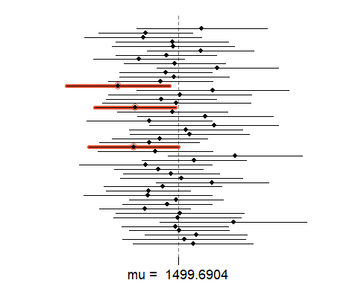

### Using the plot_ci command in R we can see that there are 57 items out of 60 include the true population mean. The proportion is exactly equal to the confidence level of 95%. It is possible that the results could differ by having more items include the true population mean. We are expecting at least 95% of the items to include the true population mean.

## 2. What is the appropriate critical t value for a 98% confidence level with 59 df? Include R calculations for finding this critical t. (It could be helpful to also find the critical t using the invT command on your graphing calculator. Confirm that you get the same result using both methods to ensure that you used the correct R command.)

qt(.975, 59) #98% confidence interval

## [1] 2.000995

## 3. Construct fifty 98% confidence intervals. You do not need to obtain new samples; simply calculate new intervals based on the sample means and standard deviations you have already collected; you only need to change the critical t used in the calculations (it was 2 for a 95% confidence level and 59 df). Using the plot_ci function, plot all fifty intervals and calculate the proportion of intervals that include the true population mean. How does this percentage compare to the confidence level?

conf_lower<- samp_mean - qt(.975,59) * samp_sd/sqrt(n)  
conf_upper<- samp_mean + qt(.975,59) * samp_sd/sqrt(n)  
plot_ci(conf_lower, conf_upper, mean(population))

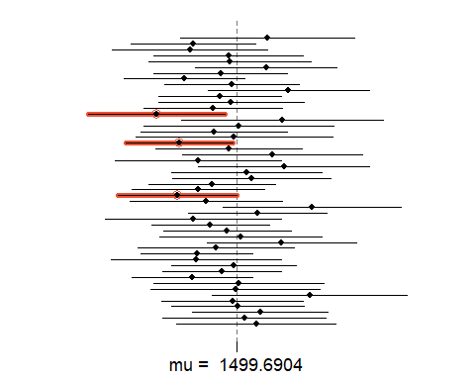

### The percentage is the same as in Homework problem 1. There are 57 items that intersect the true population mean.